CSA05-DATABASE MANAGEMENT SYSTEMS
LAB OBSERVATION
EXPERIMENT:14
AIM:
To learn how to use various TCL commands Commit, Savepoint and Rollback SQL commands
QUESTION:
Problem 1:
Create a following table Class and insert values into it in the following order and create savepoints in between
them. Try to rollback the save point and check your output by giving select commands.
Let us use some SQL queries on the above table and see the results.
UPDATE class SET name ='bravo' WHERE id ='5';
SAVEPOINT A;
INSERT INTO class VALUES('uppal', 6);
SAVEPOINT B;
INSERTINTO class VALUES(‘balu’, 7);
SAVEPOINT C;
Now let's use the ROLLBACK command to roll back the state of data to the savepoint.

SQL QUERIES:
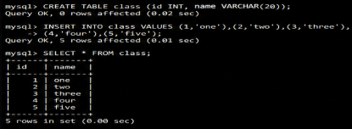
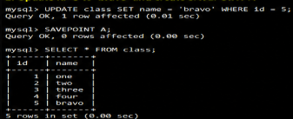
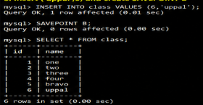
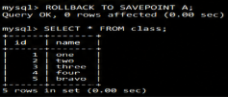
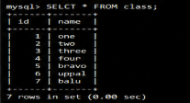
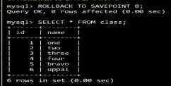
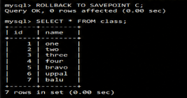
RESULT:
The commands SQL COMMIT, ROLLBACK and SAVEPOINT are implemented and result is verified.

